# FW- HW Integration Document

## Document details

This document includes the HW required information in order to implement specific application FW for PFM_SA_v1p0[07-18]] PCB.

***Creation date***: 23 July 2018 ***Last modification date***: 23 July 2018

***Revision***: 1.0

***Contributors***: Francisco Jiménez

***Revision history:***

|  |  |  |
| --- | --- | --- |
| ***Date*** | ***Contributor*** | ***Changes*** |
| 23 July 2018 | Fco. Jiménez | Initial release. |
|  |  |  |

## Microcontroller

|  |  |  |  |  |  |
| --- | --- | --- | --- | --- | --- |
| **HW PCB** | PFM_SA_v1p0[07-18] | **Revision** | 1p0 |  |  |
| **Microcontroller** | STM32F215RE | **Int.RAM Size** | 132Kb | **Int. EEPROM Size** | No |

### Micro Footprint & pinout

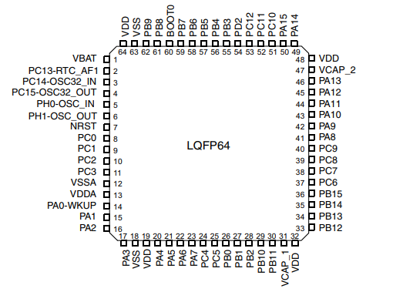

## Peripherals

|  |  |  |  |  |  |
| --- | --- | --- | --- | --- | --- |
| **Peripheral** | **Description** | **Interface** | **Microcontroller Interface** | **Pins** | **Comments** |
| M95 | GPRS Transceiver | UART/GPIO | UART6 | PC7, PC6 |  |
| GPIO | PA12, PA11, PC2, PC1, PC9, PB15 |
| SDCard | SD writer /reader | SD | SD | PC12, PC8, PD2, PB1 |  |
| Photodiode | Photodiode Optic Fiber | GPIO | GPIO | PA6, PC5, PB14 |  |
| STC3115AIQT | Battery monitoring | I2C | I2C | PB6, PB7 |  |

## Microcontroller Configuration

The following image shows the microcontroller configuration. The signal names appear as they are routed in PCB design.

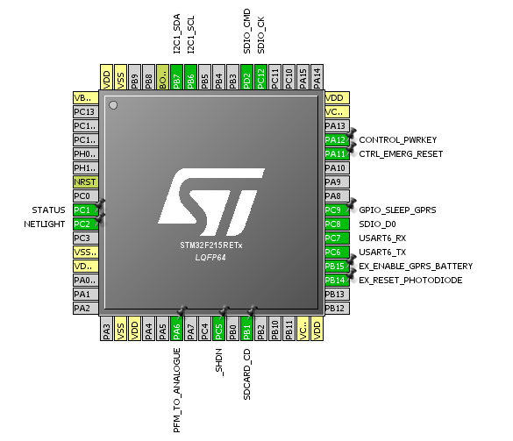

## Annex. 1: Pinout Description



|  |  |  |  |
| --- | --- | --- | --- |
| **Signal Name** | **Microcontroller**  **PIN / NAME** | **Configuration** | **Comments** |
| EX_ENABLE_GPRS_BATTERY | 36 / PB15 | GPIO Output | To enable M95 power. |
| EX_RESET_PHOTODIODE | 35 / PB14 | GPIO Output | To enable photodiode power |
| GPIO_SLEEP_GPRS | 40 / PC9 | GPIO Output | M95 go to slee. |
| SDIO_CK | 53 / PC12 | SD | SD Clock |
| SDIO_D0 | 39 /PC8 | SD | SD 1 bit data |
| SDIO_CMD | 54 / PD2 | SD |  |
| SDCARD_CD | 27 / PB1 | SD | SD card detect |
| B4_USART6RX | 38 / PC7 | UART6 RX |  |
| A17_USART6TX | 37 / PC6 | UART6 TX |  |
| /SHDN | 25 / PC5 | GPIO Output | To enable LTC6268 amplifier |
| NETLIGHT | 10 / PC2 | GPIO Input |  |
| STATUS | 9 / PC1 | GPIO Input |  |
| SDA | 59 / PB7 | I2C | SDA signal |
| SCL | 58 / PB6 | I2C | SCL signal |
| PFM_TO_ANALOGUE | 22 / PA6 | ANALOGUE PORT ADC1_IN6 |  |
| CONTROL_PWRKEY | 45 / PA12 | GPIO Output |  |
| CTRL_EMERG_RESET | 44 / PA11 | GPIO Output |  |

**Annex 1: HW Schematics**

The following OLE object shows all HW schematic pages.

## 

## Annex 2: Links to peripheral documents.

## Microcontroller

* [STM32F215RE – STMicroelectronics]

https://www.st.com/resource/en/datasheet/stm32f215re.pdf

## Peripherals

* [M95 - Quectel]

<https://www.soselectronic.com/a_info/resource/c/quectel/M95_HD_V1.0.pdf>

* [ LTC6268 - Linear]

<http://www.analog.com/media/en/technical-documentation/data-sheets/62689f.pdf>

## Annex 3: True Studio Cube project.

RAR file contains basic files with HAL drivers and pins definitions.

